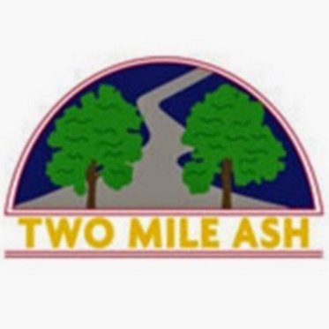

Dear Parent and Carers

It is with regret that we have been informed by our catering company AIP, that there will be a menu change coming into place from Monday 24 January 2022.

Unfortunately for reasons out of our control, we have needed to remove all bookings from our system and need to ask our parents to re book all meal choices until half term.  We are aware that the current cut-off date to confirm bookings for next week is today.  To secure meals for next week, we have extended the booking period  to Sunday 23 January 2022.

We appreciate this is not an ideal situation and AIP are very apologetic for the inconvenience this will cause.  Please see the attached letter from AIP which explains the situation in more detail.

Thank you for your help and understanding.

TMA School

Two Mile Ash School | The High Street | Two Mile Ash | Milton Keynes | MK8 8LH

01908 562262