**Year 5 Staffing Structure - September 2021**

Text Box

Text Box

Text Box

Text Box

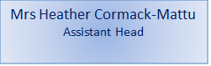 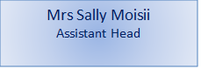

Text Box

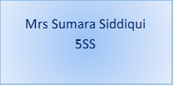 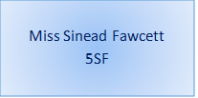 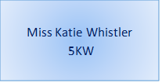 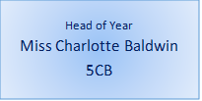

Mrs Zennah Mogul