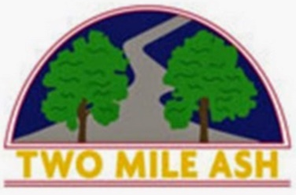
25 January 2022

Year 5 & 6 Gymnastics Trial

Dear Parents/ Carers,

On Monday 7th March 2022, a team of six Year 3/4 pupils and six Year 5/6 pupils will get the chance to represent Two Mile Ash at the Milton Keynes Schools Gymnastics Competition at MK Gym, Kingston. To help with the selection process for this event, we are holding a trial at Two Mile Ash School on Thursday 3rd February 2022 from 3:30pm-4:30pm. Collection from Main Reception at 4:30pm.

At the competition, three pupils will perform a Body Management Routine while the other three perform a Floor Exercise Routine. All six pupils will then compete in the Vault from a springboard. Details of the skills necessary for these routines are attached.

To be considered for the team it is important that children can already complete the listed skills confidently and competently. Please only enter your child for trials if you feel they can compete in either the Body Management or Floor Exercise routines, and are able to use a springboard to vault.

At the trials, children are asked to come to school in Two Mile Ash PE kit (Black jumper, Red T-Shirt, Black Shorts / Leggings / Jogging bottoms and trainers). The trial will be in the Hall so if they want to remove layers (jumper / jogging bottoms for example) for comfort then they can. Please can you also provide your child with a bottle of water so they stay hydrated.

We have been fortunate to secure a series of three lunchtime training sessions for the teams following this trial to be held at MK Springers Gymnastics Centre. If your child is chosen to represent Two Mile Ash School, these training sessions would be pivotal in preparing your child for the competition in March. Specialist coaching and fantastic facilities at MK Springers will be provided.

To attend the trial session at Two Mile Ash School on Thursday 3rd February, please complete the permission form attached confirming your child’s attendance and return it to Mr Saville by Wednesday 2nd February 2022. If you have any questions please contact us at: head@tma.bucks.sch.uk.

Thank you for your continued support.

Yours sincerely,

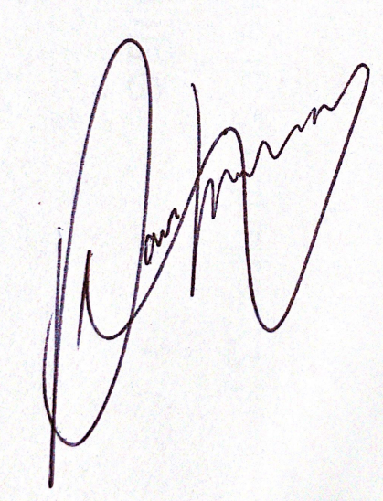
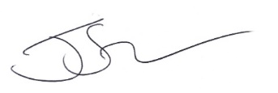
Mr. Saville Mr. Hobley
Head of PE PE Coordinator

Two Mile Ash School Practice/Fixture Permission Form

Year 5 & 6 Gymnastics Trials @ TMA. Thursday 3rd February 2022 – 3:30pm-4:30pm

Child’s Name: ______________________________________ Class: ____________

Emergency Contact Details: Name: _________________________________ Number:__________________

I give permission for my child to attend the trial (tick)

I will collect my child after the trial from TMA Main Reception at 4:30pm (tick)

Please tick the preferred routine your child would like to perform in at the trial:

Body Management

Floor Exercise

Signed (parent): Date:

Year 5/6 Body Management Routine
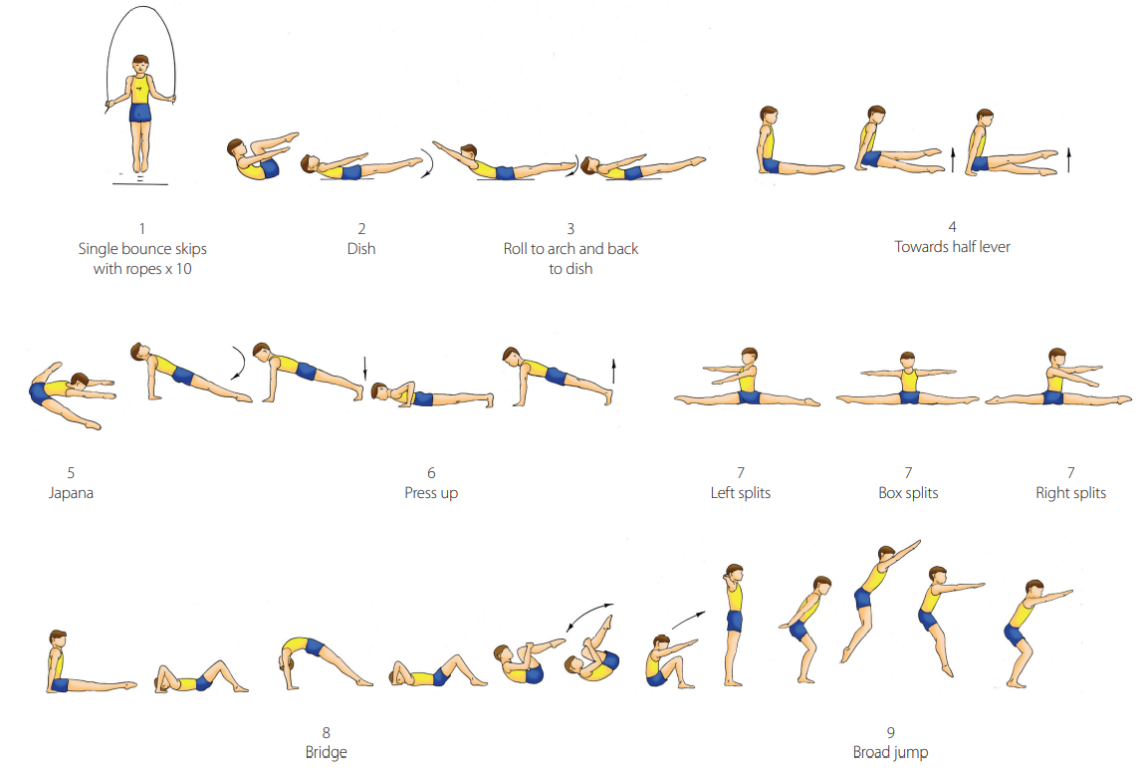
Year 5/6 Floor Exercise Routine
