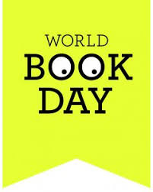

Dear Parent/Carer,
World Book Day will be upon us on Thursday 3rd March and we have planned lots of exciting events and activities to make this year’s World Book Day a great one:
Dressing Up
Like every World Book Day at Two Mile Ash school, we are inviting all pupils to dress up as one of their favourite book characters and have the opportunity to amaze us with their costumes. As well as a character, we have added a little twist. How about dressing up as a WOW word? Children can choose words that will impress the other children. We are really looking forward to the discussion that this will generate, as we look at the costumes in class. Please attach a label to your child’s outfit with the word. Have a look below to see some great ways that this can be done:
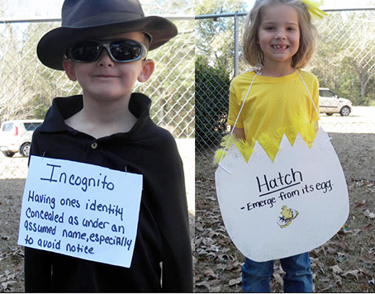
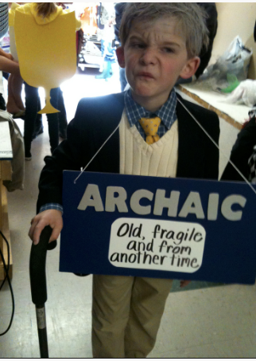
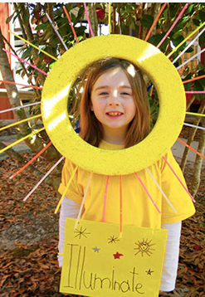

We are looking forward to sharing the activities that we have planned for World Book Day on the website and Facebook. We are asking our pupils to bring their finished potato characters on Tuesday 1st March, so that we can share and display these for World Book Day.

Thank you for your on- going support.

Happy Reading!
Monica Sharma (Head of English)

