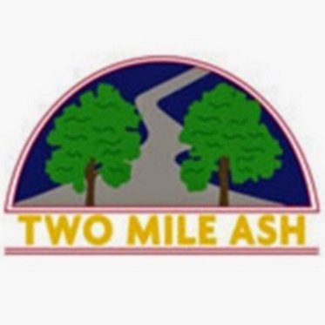

Dear Parent/Carer,

TMA Year 6 Leavers Hoodie - 2nd sale release!!

We are happy to let you know that due to high demand we are advertising a second release for the Year 6 leavers hoodies, this is only available to parents who missed the first release sale.

Please order carefully to make sure you do not duplicate a previous order, refunds will not be available after 22/03/22 when the order has been processed. There will be no orders accepted after 22/03/22 as this is the final deadline.

Once payment has been made on ParentPay for the size you require please email finance@tma.bucks.sch with your child's name and class and initials to go on the Hoodie - if you wish to have initials.

Kind regards,

Many Thanks

The Year 6 Team, Mr Saville and Finance Department

Finance@tma.bucks.sch.uk

Two Mile Ash School