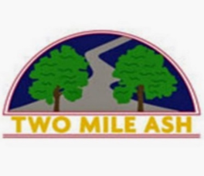

**Lost Property**

Dear parent/carer,

The school has accumulated a lot of lost property, school jumpers, PE jumpers and coats.

School uniform and other items that have names on will be returned to the child as soon as possible**.**

However, if your child is missing any unlabelled items, you can email [reception@tma.bucks.sch.uk](mailto:reception@tma.bucks.sch.uk) with the child's name, class, a description of missing item and size.

Belongings can then be returned to your child with their name written on the item.

To help reduce this problem, please remember all items that come to school with your child should be clearly labelled.

Thank you,

Reception team.