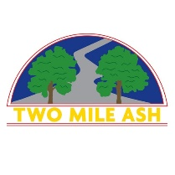

Dear Parents and carers,

During the week of the 16th – 21st May the Year 5 children that are not going to the Isle of Wight will be having an Enterprise Week. They will be researching, designing, making and selling their own products to the rest of the school.
During break times on Tuesday 17th, Wednesday 18th and Thursday 19th they will be showing their products to the rest of the school and giving them a chance to order them. The Year 5’s will then make the products and deliver them to classes.
The children will be making bracelets, pet rocks, T-shirts and badges.
If your child would like to order anything from the Enterprise Team then they will need to bring in some money. Prices will vary from 50p to £4. Please ensure that they bring in a named wallet. Any money that the children bring in is their responsibility to look after.
The Year 5 children are very excited about this project. Thank you in advance for supporting our team.

Mrs Pidgeon and Miss Fawcett

