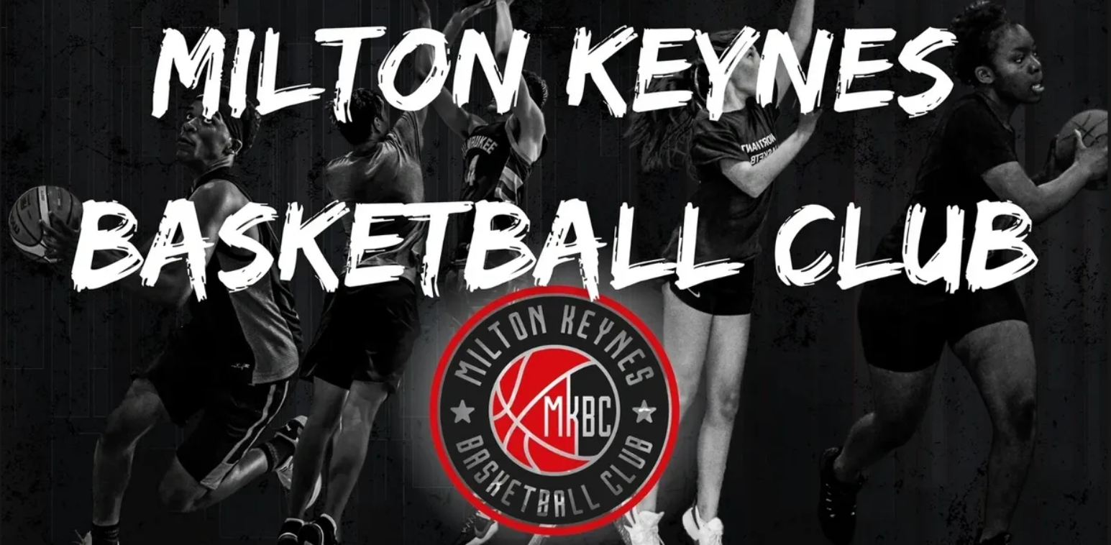
May 2022
MK Basketball Lunchtime Club @ TMA
Dear Parents/Carers,
I am writing to inform you that following the popularity of our lunch and after school clubs with MK Basketball Club, Two Mile Ash School have secured further opportunities for pupils to receive Basketball coaching from MK Basketball Club during Lunchtimes. These sessions, aimed at boys and girls of all abilities, will be led by an experienced and fully-qualified Basketball Coach at Two Mile Ash School.
There are only twenty spaces available per year group for a six-week block of sessions (dates listed below). The sessions are for 30 minutes.
As the sessions will run during lunchtime, children will be given time at school before the session to eat their lunch. Children will need to come to school in their PE Kit on the day of the sessions, including their Red TMA T-Shirt, Black leggings/shorts/joggers, Black Jumper and Trainers. They should also ensure they have a bottle of water to take with them and are wearing sunscreen on sunny days.
The total cost for the five sessions is £6.00. Bookings for these sessions go live on Parent Pay at 9am, Thursday 26th May 2022 until 9am, Friday 27th May 2022.
If you have any questions regarding this opportunity, please email Mr Saville at: head@tma.bucks.sch.uk
Session Dates & Times:
Mondays:  June: 06, 13, 20 & 27  July: 04 & 11 | Year 5 | 12:15-12:45pm
 | Year 6 | 12:45-1:15pm
Wednesdays:  June: 08, 15, 22, 29  July: 06 & 13 | Year 4 | 12:15-12:45pm
 | Year 3 | 12:45-1:15pm
Yours sincerely,
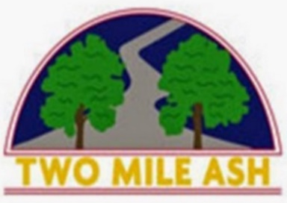
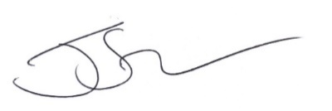
Mr. Jake Saville
Head of PE & Enrichment Coordinator
Two Mile Ash School

