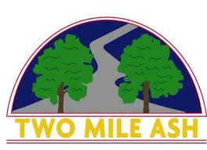

Dear Parents/Carers, September 2022

Author visit to our school!
We are very excited to announce that on the 22nd September, the author Alex Bellos is visiting our school! Alex writes for the Guardian newspaper and has written many books, including helping the footballer, Pelé, to write his autobiography. He has presented films for the BBC about football in South America and also enjoys writing about maths.

Below are two extracts from different books. One extract is from his book Football School: The Greatest Ever Quiz Book which contains over 300 questions! The other is an extract from Football School Season 2: Where Football Explains the World.
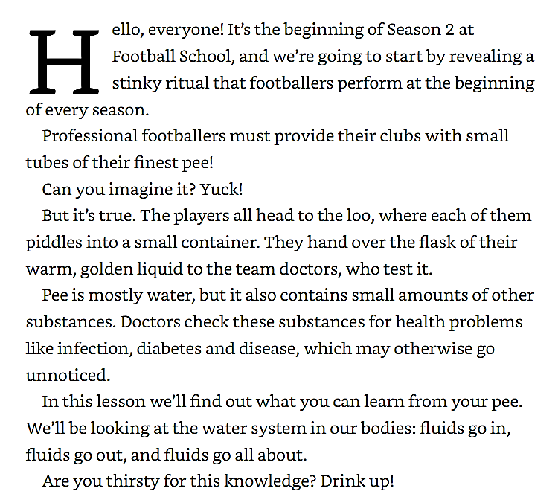
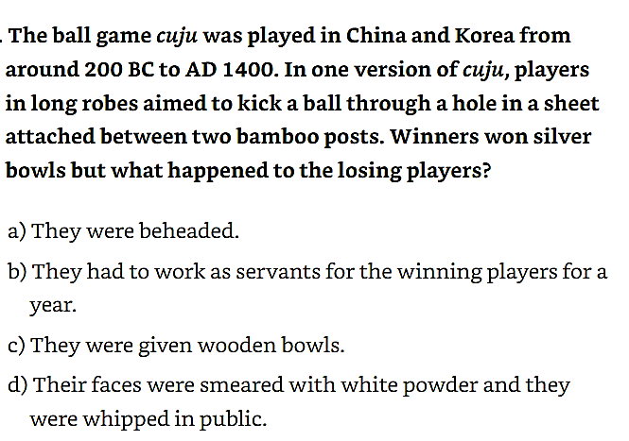

We are extremely lucky to, not only have Alex visiting us, but for him to be happy signing copies of his book for our pupils. Any books bought on parentpay prior to his visit will be signed by Alex on 22nd September after he has finished his talk to each year group.

Should you wish to purchase a book, please complete the form on parentpay with your payment.
The final date for payment is Friday, 16th September.

Yours sincerely,

Debbie Ismail
English Faculty

AUTHOR VISITING TWO MILE ASH SCHOOL!

Title | Price | Tick to Order a copy
Season 1 | £6.99 | 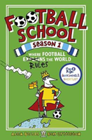 | Terrific Teams | £6.99 | 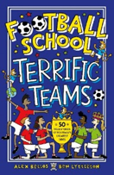
Season 2 | £6.99 | 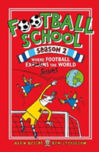 | Star Players | £6.99 | 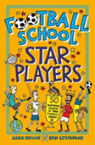
Season 3 | £6.99 | 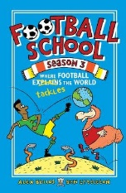 | Epic Heroes | £6.99 | 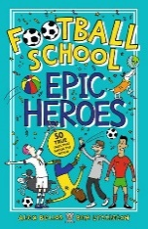
Season 4 | £6.99 | 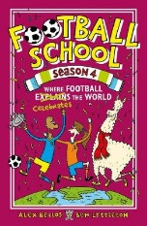 | Greatest Ever Quiz Book | £6.99 | 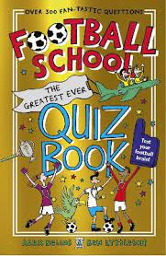
Incredible Joke Book | £5.99 | 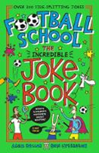

This page is purely for information. Should you wish to order any book, please do so via parentpay by Friday, 16th September. Ordered books will be given to your child by Alex, signed by him, after his talk on 22nd.

PLEASE NOTE THAT 9p WILL BE ADDED TO ALL BOOKS TO COVER THE PARENT PAY CHARGES.

