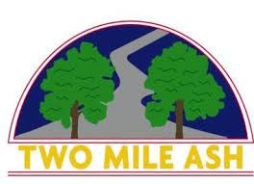

Good afternoon,  
  
Just a reminder that all extra-curricular and extended clubs have now finished for the term.  
  
Many thanks,  
TMA