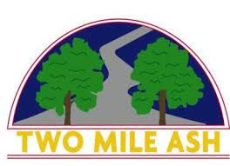

Dear parent/carer,  
  
The DFE released SATS results to schools today (Tuesday 5th July). Once we have checked these results and uploaded them onto results sheets for parents/carers we will send them out via parent-mail with their end of year reports.  
  
Many thanks,  
  
The Year 6 Team  
  
Tom Ruffett  
Head of Year 6  
  
Two Mile Ash School | The High Street | Two Mile Ash | Milton Keynes | MK8 8LH  
01908 562262