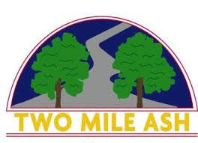

Dear Parent/ Carer,  
  
Firstly, we would like to appologise in the delay for you receiving end of year reports. We have recently moved over to a new operating system and this has caused unforeseen complications.   
Our admin team are working to ensure all reports will be sent out today and tomorrow. Year 5 and 6 reports have been sent over the last few days so if you're a Year 5 or 6 parent and haven't received your child's report, please get in contact with reception and we will try and rectify this for you.  
  
Thank you for your understanding.  
Two Mile Ash School