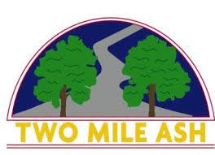

Dear Parent/carer,  
  
Ref: Guitar 1-1 lessons  
  
We wanted to let you know that there will be 1-1 Guitar lessons available on Thursday Afternoons.  
  
Please copy and paste the following link for sizing guidelines: <http://www.shepherdguitar.com/the-guitar/>  
  
Lunchtime lessons based at Two Mile Ash School:  
  
1 to 1 = 20 mins £15  
2 to 1 =20 mins £10  
  
If your child would be interested, please contact Lukefordmusic@gmail for more information (Luke Ford).  
  
Finance Department  
Two Mile Ash School

Two Mile Ash School | The High Street | Two Mile Ash | Milton Keynes | MK8 8LH

01908 562262