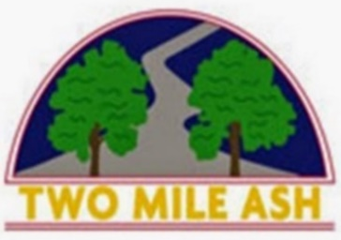

House Football
5 July 2022

Dear Parents/ Carers,

On Wednesday 6th July, the UEFA Women’s Euros kick off! This amazing football tournament is being hosted by England, with Milton Keynes one of nine host locations – there will be four matches held at Stadium MK including three Group B games and a Semi-Final on Wednesday 27th July!

To celebrate, we will be holding a series of House Football competitions at lunchtime on our school field. We would therefore like to invite all child, both boys and girls, to take part with the aim to have as much fun as possible!

The competitions will be held on the following dates and times. Children should meet Mr Saville or Mr Hobley at the field gate AFTER they have eaten their lunch.

- Tuesday 5th July 2022 – Year 4  - Wednesday 6th July 2022 – Year 5 | - Thursday 7th July 2022 – Year 3  - Friday 8th July 2022 – Year 6
Children are asked to come to school in Two Mile Ash PE kit (House Colour T-Shirt, Black Leggings or Shorts or Jogging bottoms and trainers). As the ground is hard, children will not need to wear football boots. Shin pads are advised and should be worn under socks ideally. Please can you also provide your child with a bottle of water and ensure they have applied sunscreen in the morning.

Whilst there is no need to confirm your child’s attendance at the sessions listed above, if you have any questions please contact us at: reception@tma.bucks.sch.uk.

Thank you for your continued support.

Yours sincerely,
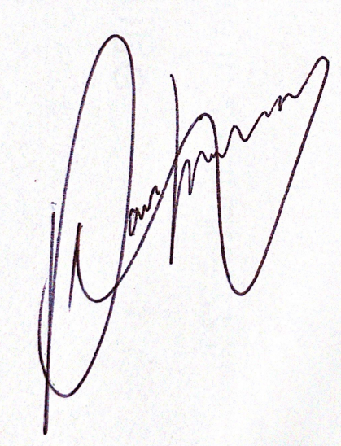
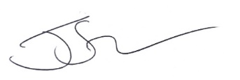
Mr. Saville Mr. Hobley
Head of PE PE Coordinator

