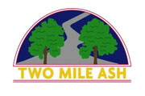

Two Mile Ash School
Physical Education
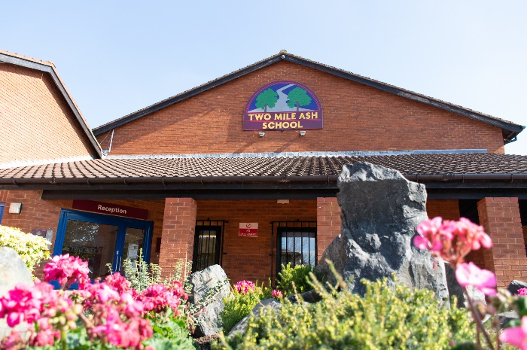
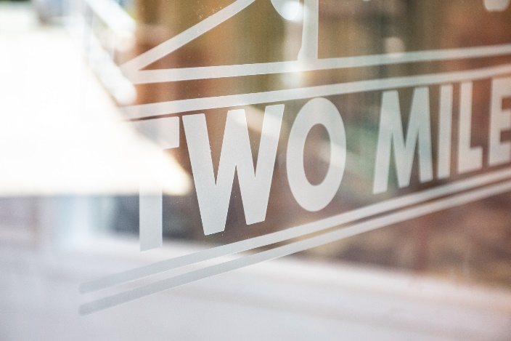
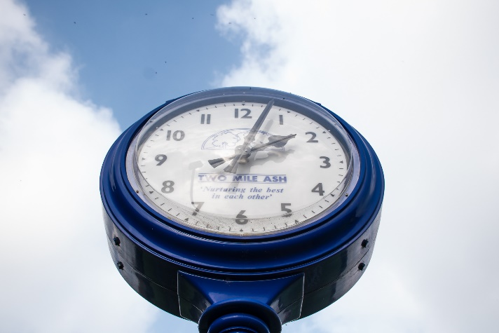

INTENT
National Curriculum
Confident Individuals
Responsible Citizens
Successful Learners

At Two Mile Ash School, we believe that Physical Education (PE), physical activity & school sport plays a vital part of school life and our children’s future health and well-being. It is therefore important our children understand the importance of leading a healthy, active lifestyle to prepare them for secondary school and beyond.

Our intent is to provide an inspirational, broad and balanced PE curriculum that ensures ALL children develop a love of physical activity. We aim to harvest this joy through the enhancement of existing skills, the learning of new skills and the introduction to new sports, clubs, school teams and external clubs.

Two Mile Ash School believes that regularly participating in physical activity and sporting activity is a key element of developing a school in which pupils are proud of the community in which they belong. Therefore, great emphasis is placed upon providing additional sporting opportunities beyond the ‘classroom’. Our extra-curricular programme consists of many after-school clubs, inter-house and intra-school competition and festivals as well as directly supporting local clubs within Milton Keynes.

It is our intent to fully deliver and build upon the aims of the national curriculum for PE to meet the needs of our pupils. The aims of PE national curriculum (2014) are:
- develop competence to excel in a broad range of physical activities
- are physically active for sustained periods of time
- engage in competitive sports and activities
- lead healthy, active lives.

We believe this links directly with our school’s vision & values, and is another way in which we positively engage with our local community and are active citizens within it.

Essential Objectives (Our End Points)
What we want children to be able to do or know by the time they leave.
Successful Learners
Confident Individuals
Responsible Citizens

Physical Education

To outwit opponents through games activities
To explore and communicate ideas and emotions through dance activities
To identify and solve problems through outdoor and adventurous activities

To accurately replicate actions, phrases and sequences through gymnastic activities

To perform at maximum levels through athletic, fitness and swimming activities

Long Term Plan (What’s taught when)
PE
Years 3 and 4 - Milestone 2

MILESTONE 2  Autumn Term | MILESTONE 2  Spring Term | MILESTONE 2  Summer Term
Year 3  E.O To develop practical skills in order to participate, compete and lead a healthy lifestyle.  Fundamental skills  - There are some good examples of skills developing and strengths are emerging in some areas.  - Throwing and catching is becoming accurate, ball skills are developing and there is some development of more advanced tactics.  - Fair play is understood and there is some good cooperation with team-mates.  Invasion Games-Football  - Generally, skills are developing well in most areas. Control and accuracy are developing well in a range of situations.  - Advanced tactics are devised and used well to gain advantage over opponents.  - Fair play is generally adopted and there is a good level of communication and cooperation with team mates.  Fitness/Indoor athletics  - Generally, athletics skills well developed.  - Sprints are becoming powerful and an ability to converse energy over longer distances gives a competitive advantage.  - Jumping is becoming strong and landings controlled  - Throwing is becoming accurate and powerful.  Year 4  E.O to develop practical skills in order to participate, compete and lead a healthy lifestyle.  Badminton  - Skills are well developed in almost all areas where they are highly developed.  - Excellent control, accuracy and well-devised tactics are shown which outwits opponents.  - Fair play is always paramount and there is an excellent sense of team.  Invasion Games-Football  - Skills are well developed in almost all areas where they are highly developed.  - Excellent control, accuracy and well-devised tactics are shown which outwits opponents.  - Fair play is always paramount and there is an excellent sense of team.  Hockey  - Skills are well developed in almost all areas where they are highly developed.  - Excellent control, accuracy and well-devised tactics are shown which outwits opponents.  - Fair play is always paramount and there is an excellent sense of team.  Indoor Athletics  - Athletics skills very well developed in all areas and highly developed in some.  - Sprints are powerful and speed is sustained over distance, whilst over longer distances, careful planning of pace conserves energy.  - Throwing is accurate and powerful.  Swimming  - Swimming skills are well developed in all areas where they are highly developed.  - Speed is achieved very well and more than one stroke is used. There is fluent, coordinated movement at and below the surface of the water. | Year 3  E.O to develop practical skills in order to participate, compete and lead a healthy lifestyle.  OAA  - Outdoor Adventurous activity skills are generally developing well.  - The right equipment is brought to activates and there is a good awareness of risks and steps are suggested to help manage them.  - Teamwork is well developed including some leadership responsibilities.  - Orientation skills are well developed.  Gym  - Generally, gymnastics skills are developing well in most areas. Planning and refinement is effective and sequences are clear, fluent and expressive.  - Good changes in direction, speed, levels and balance are fluent.  - Alignment and there is a good awareness of body position.  Dance  - Skills developing well in most areas.  - Planning and performances of sequences of moves are well devolved and movement is clear, fluent and expressive.  - Dances convey a definite idea well and strength and suppleness is shown in well-coordinated changes in height, speed, level and direction.  Invasion Games/Netball  - Generally, skills are developing well in most areas.  - Control and accuracy are developing well in a range of situations.  - Advanced tactics are devised and used well to gain advantage over opponents.  - Fair play is generally adopted and there is a good level of communication and cooperation with team mates.  Year 4  E.O to develop practical skills in order to participate, compete and lead a healthy lifestyle.  OAA  - Skills are well developed in almost all areas where they are highly developed.  - Excellent control, accuracy and well-devised tactics are shown which outwits opponents.  - Fair play is always paramount and there is an excellent sense of team.  Gym  - Gymnastics skills are well developed in all areas and there are a few areas where they are highly developed.  - Planning of exceptionally well-refined sequences that are fluent and expressive are performed with high level of control and poise.  - Dynamic movement that is gained through excellent strength, balance and awareness of body position.  Dance  - Dance skills are well developed in all areas and there are few areas where they are highly developed.  - Performances show excellent movement that is strong, fluent, coordinated and highly expressive.  - Ideas for expressing a mood are defined and implemented extremely effectively.  - Shapes are strong and stretches show a high level of suppleness.  Netball  - Skills are well developed in almost all areas where they are highly developed.  - Excellent control, accuracy and well-devised tactics are shown which outwits opponents.  - Fair play is always paramount and there is an excellent sense of team.  Swimming  - Swimming skills are well developed in all areas where they are highly developed.  - Speed is achieved very well and more than one stroke is used.  - There is fluent, coordinated movement at and below the surface of the water. | Year 3  E.O to develop practical skills in order to participate, compete and lead a healthy lifestyle.  Striking and fielding  Athletics  - Generally, athletics skills well developed.  - Sprints are becoming powerful and an ability to converse energy over longer distances gives a competitive advantage.  - Jumping is becoming strong and landings controlled.  - Throwing is becoming accurate and powerful.  Rounders  - Generally, skills are developing well in most areas.  - Control and accuracy are developing well in a range of situations.  - Advanced tactics are devised and used well to gain advantage over opponents.  - Fair play is generally adopted and there is a good level of communication and cooperation with team mates.  Tennis  - Generally, skills are developing well in most areas.  - Control and accuracy are developing well in a range of situations.  - Advanced tactics are devised and used well to gain advantage over opponents.  - Fair play is generally adopted and there is a good level of communication and cooperation with team mates.  Year 4  E.O To develop practical skills in order to participate, compete and lead a healthy lifestyle.  Athletics  - Athletics skills very well developed in all areas and highly developed in some.  - Sprints are powerful and speed is sustained over distance, whilst over longer distances, careful planning of pace conserves energy.  - Throwing is accurate and powerful.  Rounders  - Skills are well developed in almost all areas where they are highly developed.  - Excellent control, accuracy and well-devised tactics are shown which outwits opponents.  - Fair play is always paramount and there is an excellent sense of team.  Tennis  - Skills are well developed in almost all areas where they are highly developed.  - Excellent control, accuracy and well-devised tactics are shown which outwits opponents.  - Fair play is always paramount and there is an excellent sense of team.  Swimming  - Swimming skills are well developed in all areas where they are highly developed.  - Speed is achieved very well and more than one stroke is used.  - There is fluent, coordinated movement at and below the surface of the water.

PE
Milestone 3

MILESTONE 3  Autumn Term | MILESTONE 3  Spring Term | MILESTONE 3  Summer Term
Year 5  E.O: To develop practical skills in order to participate, compete and lead a healthy life style.  Hockey  - Generally, games skills are well developed in most areas. Control and coordination is good and tactic, moves and techniques well developed.  - Solo and team efforts are sustained in a wide range of game situations.  - The direction of play is usually anticipated and used to plan ahead, giving a competitive advantage over opponents. Attacking and defending is confident and the roles of team player and leader are developing well, always within the spirit of fair play.  Badminton and Basketball  - Generally, games skills are well developed in most areas. Control and coordination is good and tactic, moves and techniques well developed.  - Solo and team efforts are sustained in a wide range of game situations.  - The direction of play is usually anticipated and used to plan ahead, giving a competitive advantage over opponents. Attacking and defending is confident and the roles of team player and leader are developing well, always within the spirit of fair play.  Athletics  - Athletics skills are generally well developed in most areas.  - Sprinting with hurdles is well developed over 60 metres and good decisions are made on body position for running over a variety of distances.  - Throwing is generally accurate and refinements through analysis of technique are naturally made.  - Take-offs and landings are controlled and targets to beat personal bests in a range of activities are set.  Year 6  E.O: To develop practical skills in order to participate, compete and lead a healthy life style.  Badminton  - Games skills are well developed in all areas and highly developed in some.  - Exceptional control and coordination is shown in a wide range of situations.  - Tactics are very well planned.  - Competitive efforts are sustained in a wide range of situations.  - Highly perceptive observations of the movement of play help in planning excellent strategies to gain a competitive advantage over opponents.  - The roles of leader and team player are very well developed and there is a strong spirit of fair play.  Hockey  - Games skills are well developed in all areas and highly developed in some.  - Exceptional control and coordination is shown in a wide range of situations.  - Tactics are very well planned.  - Competitive efforts are sustained in a wide range of situations.  - Highly perceptive observations of the movement of play help in planning excellent strategies to gain a competitive advantage over opponents.  - The roles of leader and team player are very well developed and there is a strong spirit of fair play.  Indoor Athletics  - Athletics skills are well developed in all areas and highly developed in some.  - Sprinting with hurdles over 60 meters is very efficient and there are some good awareness of different running positions required for a variety of distances.  - Throwing is very accurate and there is a high degree of analysis of technique.  - Take-offs and landings are very accurate and well planned. Targets to beat personal bests are made and achieved.  Basketball  - Games skills are well developed in all areas and highly developed in some.  - Exceptional control and coordination is shown in a wide range of situations.  - Tactics are very well planned.  - Competitive efforts are sustained in a wide range of situations.  - Highly perceptive observations of the movement of play help in planning excellent strategies to gain a competitive advantage over opponents.  - The roles of leader and team player are very well developed and there is a strong spirit of fair play. | Year 5  E.O: To develop practical skills in order to participate, compete and lead a healthy life style.  OAA  - Outdoor and adventurous activity skills are generally well developed.  - The correct equipment is selected and packed appropriately. Possible risks are identified and suggestions given as to how they may be minimised, seeking the advice of experts, if required.  - Both leadership and team roles are embraced and some good examples of showing support and encouragement are developing.  - Experts are always consulted if there is any doubt and a positive outlook maintained throughout.  - There is a good awareness of the need to watch out for changing conditions, adapting plans as necessary.  Gym  - Gymnastics skills are generally well developed in most areas. Complex sequences contain a full range of movement are executed.  - Strong, fluent and expressive shapes are held well, including set pieces.  - Appropriate linking elements are chosen and decisions about speed, direction, level and body rotation are well made. Strong position shows a good bodily awareness. The use of equipment to vault and swing is developing well.  Dance  - Dance skills are generally well developed in most areas. Composition of pieces is creative and imaginative and performances strong with good posture.  - More complex sequences are developed, which show original and expressive ideas.  - A good mixture of high energy and slower, more graceful movements are planned and sustained throughout a performance.  - There is a strong display of strength and stamina and a good use of gymnastic skills.  Rugby  - Generally, games skills are well developed in most areas. Control and coordination is good and tactic, moves and techniques well developed.  - Solo and team efforts are sustained in a wide range of game situations.  - The direction of play is usually anticipated and used to plan ahead, giving a competitive advantage over opponents.  - Attacking and defending is confident and the roles of team player and leader are developing well, always within the spirit of fair play.  Year 6  E.O: To develop practical skills in order to participate, compete and lead a healthy life style.  OAA  - Outdoor and adventurous activity skills are well developed in all areas and in some they are highly developed.  - Possible risks beyond the obvious are identified and very good suggestions given on how to minimise them.  - A very watchful eye is given to changing conditions and plans are adapted accordingly.  - Advice of experts is always sought if there is any doubt.  - Both leadership and team roles are embraced in a wide variety of different contexts and some excellent examples of support and encouragement rallies the morale of others.  - A positive outlook and good companionship which gains the respect and commitment of a team are displayed.  GYM  - Gymnastics skills are well developed in all areas and highly developed in some.  - Complex sequences are very well executed and show excellent fluency and expression.  - Highly appropriate linking elements are chosen and variations in speed, direction, level and body rotation are very well judged.  - Confident and controlled use of equipment to vault and swing is developing.  Dance  - Dance skills are well developed in all areas and are highly developed in some.  - Compositions are excellent and show highly creative and imaginative ideas.  - Performances are very strong and show excellent body position and posture.  - Complex sequences are devised and contain highly original and expressive ideas.  - Well-judged changes very appropriately.  - Strength and stamina are exceptional.  Rugby  - Games skills are well developed in all areas and highly developed in some.  - Exceptional control and coordination is shown in a wide range of situations.  - Tactics are very well planned.  - Competitive efforts are sustained in a wide range of situations.  - Highly perceptive observations of the movement of play help in planning excellent strategies to gain a competitive advantage over opponents.  - The roles of leader and team player are very well developed and there is a strong spirit of fair play. | Year 5  E.O: To develop practical skills in order to participate, compete and lead a healthy life style.  Cricket  - Generally, games skills are well developed in most areas. Control and coordination is good and tactic, moves and techniques well developed.  - Solo and team efforts are sustained in a wide range of game situations.  - The direction of play is usually anticipated and used to plan ahead, giving a competitive advantage over opponents. Attacking and defending is confident and the roles of team player and leader are developing well, always within the spirit of fair play.  Tennis  - Generally, games skills are well developed in most areas. Control and coordination is good and tactic, moves and techniques well developed.  - Solo and team efforts are sustained in a wide range of game situations.  - The direction of play is usually anticipated and used to plan ahead, giving a competitive advantage over opponents. Attacking and defending is confident and the roles of team player and leader are developing well, always within the spirit of fair play.  Rounders  - Generally, games skills are well developed in most areas. Control and coordination is good and tactic, moves and techniques well developed.  - Solo and team efforts are sustained in a wide range of game situations.  - The direction of play is usually anticipated and used to plan ahead, giving a competitive advantage over opponents. Attacking and defending is confident and the roles of team player and leader are developing well, always within the spirit of fair play.  Athletics  - Athletics skills are generally well developed in most areas.  - Sprinting with hurdles is well developed over 60 metres and good decisions are made on body position for running over a variety of distances.  - Throwing is generally accurate and refinements through analysis of technique are naturally made.  - Take-offs and landings are controlled and targets to beat personal bests in a range of activities are set  Year 6  E.O: To develop practical skills in order to participate, compete and lead a healthy life style.  Cricket  - Games skills are well developed in all areas and highly developed in some.  - Exceptional control and coordination is shown in a wide range of situations.  - Tactics are very well planned.  - Competitive efforts are sustained in a wide range of situations.  - Highly perceptive observations of the movement of play help in planning excellent strategies to gain a competitive advantage over opponents.  - The roles of leader and team player are very well developed and there is a strong spirit of fair play.  Rounders  - Games skills are well developed in all areas and highly developed in some.  - Exceptional control and coordination is shown in a wide range of situations.  - Tactics are very well planned.  - Competitive efforts are sustained in a wide range of situations.  - Highly perceptive observations of the movement of play help in planning excellent strategies to gain a competitive advantage over opponents.  - The roles of leader and team player are very well developed and there is a strong spirit of fair play.  Athletics  - Athletics skills are well developed in all areas and highly developed in some.  - Sprinting with hurdles over 60 meters is very efficient and there is some good awareness of different running positions required for a variety of distances.  - Throwing is very accurate and there is a high degree of analysis of technique.  - Take-offs and landings are very accurate and well planned. Targets to beat personal bests are made and achieved.  Tennis  - Games skills are well developed in all areas and highly developed in some.  - Exceptional control and coordination is shown in a wide range of situations.  - Tactics are very well planned.  - Competitive efforts are sustained in a wide range of situations.  - Highly perceptive observations of the movement of play help in planning excellent strategies to gain a competitive advantage over opponents.  - The roles of leader and team player are very well developed and there is a strong spirit of fair play.

Progression of Knowledge and Skills
Physical Education

Essential Objective:
To outwit opponents through games activities
 |  | MILESTONE 1 - End of Year 2 | MILESTONE 2 - End of Year 4 | MILESTONE 3 - End of Year 6
HEAD | Skills |  | - Communicate with team mates to apply simple tactics | - Identify when they were successful and what they need to do to improve.  - To use the rules of the game honestly and consistently (including as official)  - Recognise own and other’ strengths and weaknesses and suggest ways to improve.
 | Knowledge |  | - To understand more rules of the game and begin to use them  - Develop an understanding of tactics and begin to use them in games  - Use knowledge of key terminology to give feedback  - To understand how to improve their performance. | - To understand the rules of the game and apply them honestly (including as official)  - To understand the need for tactics in different situations  - Know the positions they can play in within the game
HANDS | Skills |  | Invasion Games  To able to:  - dribble, pass, receive and shoot with control  - find space away from others  - move with a ball towards goal with increasing control  - track an opponent to slow them down.  - move to space to help team keep possession and score  - delay an opponent to prevent them scoring.  Striking and Fielding Games  To be able to:  - bowl a ball towards a target with some accuracy and consistency  - begin to strike a bowled ball after one bounce/with adapted equipment  - use overarm and underarm throwing and catching skills with increased accuracy.  Net/Wall and Target Games  To be able to:  - return a ball to a partner  - use basic racket skills (grip / ball balancing / ball juggling)  - accurately underarm throw & catch a ball with a partner  - sometimes play a continuous game/rally  - return to ready position to defend own side of the court. | Invasion Games  To be able to:  - dribble, pass, receive and shoot with increasing control under pressure  - often make the correct decision of who to pass to and when  - select the correct action for the situation  - use tracking and intercepting in defence  - create and use space to help my team  - use marking, tackling and/or interception to improve their defence  Striking and Fielding Games  To be able to:  - bowl a ball underarm with increased accuracy and consistency  - to begin to strike a ball with a cricket/rounders bat  - develop a wider range of fielding skills  - use a wider range of skills with increasing control under pressure  - to strike a bowled ball with increasing consistency  - to begin to demonstrate the correct overarm bowling technique.  Net/Wall and Target Games  To be able to:  - develop a wider range of skills and use these under some pressure (bump / forehand / backhand)  - use a wider range of skills with increasing control under pressure (including serving / volley / spike / dig / set)  - begin to apply different skills to different game situations  - select the appropriate action for a situation  - play cooperatively with a partner.
HEART | Skills |  | - Work cooperatively within a group to self-manage games  - To begin to play honestly and fairly.  - Communicate ideas when working with others to manage a game  - To play with fairness and honesty. | - Be able to work cooperatively with others to manage a game  - To play with fairness and honesty  - Use feedback to improve their work.
 | Knowledge |  | - Understand the benefits of exercise  - To explain what happens to the body when we exercise and how this keeps you healthy | - To identify how different activities can benefit health  - To explain what happens to the body when we exercise  - To understand there are different areas of fitness

Essential Objective:
To accurately replicate actions, phrases and sequences through gymnastic activities

 | MILESTONE 1 - End of Year 2 | MILESTONE 2 - End of Year 4 | MILESTONE 3 - End of Year 6
HEAD | Skills | - With help, recognise how performances can be improved.  - To suggest possible improvements in own and others’ performances. | - To use criteria to make simple judgements about performances and suggest ways they can be improved.  - To use feedback to improve their work
 | Knowledge | - To use key words to give feedback  - To identify some muscle groups used in gymnastics activities | - To use knowledge of appropriate key language to evaluate and refine own and others’ work  - To understand how to work safely.
HANDS | Skills | To be able to:  - complete actions with increasing balance and control (point/patch balances, rolls and jumps)  - move in unison with a partner.  - use body tension to improve control and quality of movements  - To safely perform balances individually and with a partner. | To be able to:  - use strength and flexibility to improve the quality of performance  - create and perform sequences using apparatus, individually and with a partner  - use canon and matching/mirroring when performing  - combine and perform actions, shapes and balances with control and fluency  - show examples of counter balance and tension with a partner
HEART | Skills |  | - To lead a partner through a short warm-up routine  - To work collaboratively with others to create a sequence
 | Knowledge | - To understand the benefits of exercise.  - To explain what happens to the body when we exercise. | - Understand how to work safely when learning

Essential Objective:
To explore and communicate ideas and emotions through dance activities

 | MILESTONE 1 - End of Year 2 | MILESTONE 2 - End of Year 4 | MILESTONE 3 - End of Year 6
HEAD | Skills |  | - To evaluate and refine own and others’ work
 | Knowledge | - To use knowledge of key words to provide feedback.  - Use appropriate language and vocabulary to provide feedback within lessons. | - To use key terminology to suggest ways to improve own/others work.
HANDS | Skills | To be able to:  - use dynamic and expressive qualities in relation to an idea  - create short dance phrases that communicate an idea  - repeat, remember and perform a dance phrase.  - use changes in timing and spacing to develop a dance  - choose actions and dynamics to convey an idea  - copy and remember set choreography  - Use simple movement patterns to structure dance phrases on own, with a partner and in a small group  - Use counts to stay in time. | To be able to:  - refine the use of actions, dynamics, relationships and space  - choreograph phrases considering actions and dynamics  - accurately copy and repeat set choreography  - confidently perform clearly and fluently, showing good sense of timing  - Use counts to stay in time.  - refine the use of actions, dynamics and relationships to represent ideas, emotions and feelings  - choreograph a dance safely using as prop  - perform confidently and fluently with accuracy and good timing  - Use counts when choreographing to improve the quality of work produced.
 | Knowledge
HEART | Skills | - To be respectful of others when watching them perform  - To work with a partner and small group, sharing ideas. | - To lead a group through a short warm-up routine  - To use feedback to improve their work.  - To work creatively and imaginatively on own, with a partner and a small group.
 | Knowledge | - To understand the benefits of exercise  - To explain what happens to the body when we exercise | - To identify how dance activities can benefit physical health  - To understand there are different areas of fitness and how they help in dance activities

Essential Objective:
To perform at maximum levels through athletic, fitness and swimming activities

 | MILESTONE 1 - End of Year 2 | MILESTONE 2 - End of Year 4 | MILESTONE 3 - End of Year 6
HEAD | Skills | Athletics  - To identify when they are successful and how they can improve. | Athletics  - To identify good performance and explain why it is good  - To help others improve their technique using key teaching points.
 | Knowledge |  | Swimming  - To explain several pool rules that help to keep them safe.
HANDS | Skills | Athletics  To be able to:  - successfully take part in a relay  - improve sprinting technique  - develop jumping for distance and height  - throw a variety of objects for accuracy and distance  - safely land when jumping  - start running in a relay at the appropriate time  - jump for distance and height with balance and control  - throw with some accuracy and power towards a target | Athletics  To be able to:  - choose the best pace for a running event  - perform a range of jumps showing some technique  - show control at take-off and landing in jumping events  - show accuracy and power when throwing for distance  - select and apply the best pace for a running event  - perform jumps for height and distance using good rhythm and coordination  - show accuracy and good technique when throwing for distance  Swimming  To be able to:  - float on front and back  - use arms and legs together to move across the water  - glide on both front and back  - roll from front to back and regain a standing position  - swim over a distance of at least 10m with buoyancy aid / unaided  - perform safe self-rescue  - use a range of strokes effectively  - swim confidently over a distance of at least 25m.
HEART | Skills | - To work with a partner and in a small group, sharing ideas  - To support and encourage others to do their best  - To show determination to improve their personal best. | - To take on the role of coach, official and timer when working in a group  - To use strategies to persevere to achieve personal best  - To show fair play and honesty.
 | Knowledge | - To understand why it is important to warm-up | - To understand how stamina and power help performance in different activities.  - To understand there are different areas of fitness  - To understand the benefits of regular exercise.

Essential Objective:
To identify and solve problems through outdoor and adventurous activities

 | MILESTONE 1 - End of Year 2 | MILESTONE 2 - End of Year 4 | MILESTONE 3 - End of Year 6
HEAD | Skills | - To plan and apply strategies to solve problems  - To reflect on successes in challenges. | - To use critical thinking skills to approach a task and solve challenges  - To reflect on successes when solving challenges and adapt in order to improve
HANDS | Skills | To be able to:  - follow and give instructions  - develop map reading skills  - demonstrate sustained running in orienteering activities.  - confidently communicate ideas and listen to others  - identify key symbols on a map and help navigate around a grid  - show stamina within running challenges | To be able to:  - orientate a map confidently  - navigate around a course using a map  - demonstrate increased endurance within orienteering challenges.  - orientate a map efficiently to navigate around a course  - demonstrate sustained effort when running within orienteering challenges.
HEART | Skills | - To listen and be accepting of others’ ideas  - To work collaboratively with a partner and in a small group. | - To be inclusive of others and share job roles / lead as appropriate  - To work effectively with others, sharing ideas and agreeing on strategy.  - To share ideas within a group, selecting and applying the best method to solve a problem

Example Knowledge organiser
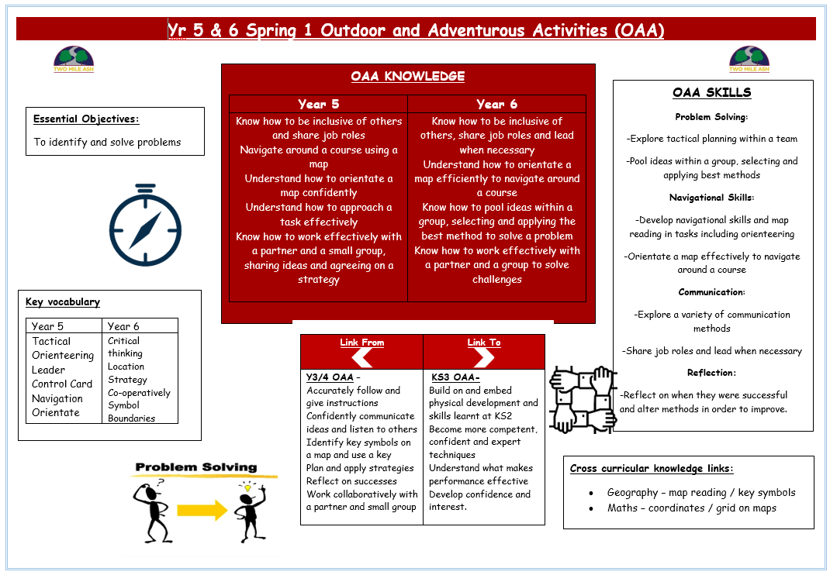

Example Knowledge organiser
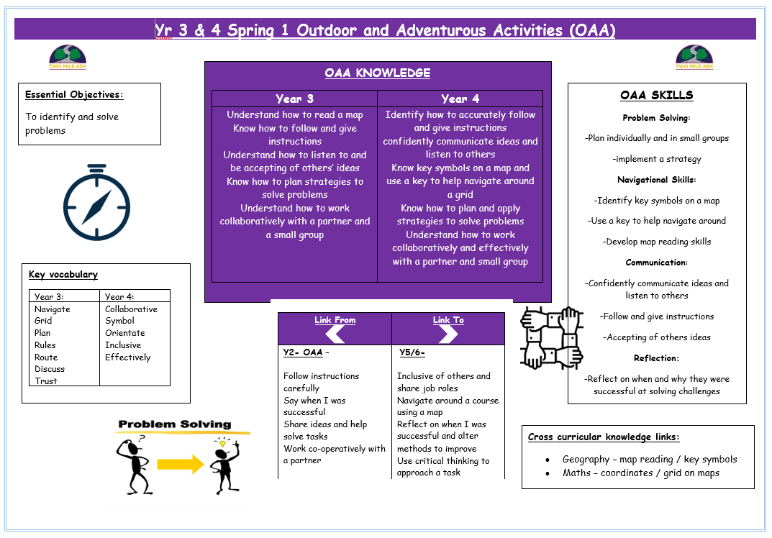

Vocabulary Progression
Physical Education

 | MILESTONE 1 - End of Year 2 | MILESTONE 2 - End of Year 4 | MILESTONE 3 - End of Year 6
GAMES | pass, team, tag, safely, forwards, backwards, balance, space, defender, attacker, points, score, dribbling, partner, receive, possession, send, goal, teammate, dodge, chest pass, bounce pass, catch, throw, ready position, net, underarm, quickly, trap, return, collect, against, hit, target, fielder, batter, bowler, roll, kick, send, aim, collect. | receiver, interception, footwork, rebound, mark, travelling, playing area, tracking, outwit, opposition, opponent, contact, pivot, court, field, pitch, grip, strike, wicket, rounder, batting, backstop, wicket keeper, fielding, bowl, stance, retrieve, stumped, short barrier, two-handed pick up, serve, racket, accurately, rally, receiver, backhand, forehand, overhead, shoulder, release | tactics, offside, control, foul, support, pressure, obstruction, onside, consecutive, formation, consistently, conceding, dictate, turnover, contest, shut down, overtake, tracking, backing up, co-operatively, drive hit, defensive hit, volley, set, dig, deep, forecourt, backcourt, defensive, attacking, sportsmanship, tournament
DANCE | move, copy, shape, space, around, travel, sideways, forwards, backwards, counts, pose, level, slow, fast, balance, mirror, action, pathway, direction, speed, timing. | flow, explore, create, perform, match, feedback, expression, reaction, dynamics, unison, control. | formation, posture, performance, canon, relationship, choreograph, phrase, contrast, structure, fluently, connect.
GYMNASTICS | move, copy, shape, over, space, rock, around, safely, travel, forwards, backwards, sideways, action, jump, roll, level, direction, speed, point, balance. link, pathway, sequence, tuck, straddle, speed, star, pike. | flow, explore, create, matching, interesting, control, contrasting, technique, quality, apparatus, perform, extension, inverted, tension | symmetrical, asymmetrical, rotation, synchronisation, aesthetics, progression, canon, formation, momentum, counterbalance, fluently, counter tension, stability, flexibility.
SWIMMING | exit, enter, front, travel, rules, safely, kicking, back, pulling, gliding, splash, floating, unaided, breathing. | sculling, crawl, breaststroke, submersion, rotation, backstroke, stroke, huddle, alternate, survival, treading water, buoyancy. | exhale, flutter kick, surface, somersault, personal best, inhale.
ATHLETICS | push, stop, jump, space, forwards, backwards, safely, balance, far, fast, improve, hop, slow, direction, aim, bend, travel. sprint, jog, distance, height, take-off, landing, overarm, underarm. | speed, strength, accurately, higher, pace, control, faster, further, power, stamina, officiate, perseverance, determination, accuracy, personal best, coordination, stamina, healthy, distance | technique, upsweep, down sweep, flight, rhythm, stride, rotation, trajectory, continuous pace, force, compete, momentum, transfer of weight, record, analyse, measure, agility
OUTDOOR AND ADVENTUROUS ACTIVITIES | team, share, path, listen, space, travel, follow, safely, lead, co-operate, teamwork, solve, instructions, support, map, direction, successful, communicate, pace, jog, sprint. | rules, route, trust, navigate, grid, discuss, plan, leader, inclusive, effectively, orientate, symbol, stamina, healthy, progress, distance | collaborate, collective, navigation, tactical, control card, orienteering, boundaries, location, critical thinking, symbol, co-operatively, strategy

Assessment Criteria
Physical Education
Milestone 2

Physical Education
Milestone 2

PHYSICAL EDUCATION - MILESTONE 2
Essential Objective: To outwit opponents through games activities
KEY INDICATORS | BASIC  (Y3 WA, Y4 WT) | ADVANCING  (Y3 GD, Y4 WA) | DEEP  (Y4 GD)
HANDS – The demonstration of physical skills including throwing, catching, striking and fielding. | dribble, pass, receive and shoot with some control  find space away from others  move with a ball towards goal with increasing control  track an opponent to slow them down.  bowl a ball towards a target  begin to strike a bowled ball after one bounce  use overarm and underarm throwing and catching skills.  return a ball to a partner  use basic racket skills (grip / ball balancing)  accurately underarm throw & catch a ball with a partner. | dribble, pass, receive and shoot with increasing control  move to space to help team keep possession and score  delay an opponent to prevent them scoring.  bowl a ball with some accuracy and consistency  strike a bowled ball after a bounce/with adapted equipment  use overarm and underarm throwing and catching skills with increased accuracy.  sometimes play a continuous game/rally  I can use a range of basic racket skills (grip / ball balancing / ball juggling)  return to ready position to defend own side of the court. | dribble, pass, receive and shoot with some control under pressure  often make the correct decision of who to pass to and when  use tracking and intercepting in defence.  bowl a ball underarm with increased accuracy and consistency  begin to strike a ball with a cricket/rounders bat  develop a wider range of fielding skills.  develop a wider range of skills and use these under some pressure (forehand / backhand)  begin to apply different skills to different game situations  begin to play cooperatively with a partner
HEAD – The thinking skills required to make appropriate decisions, follow rules and understand key vocabulary. | Understand more of the rules of the game and begin to use them  Developing an understanding of tactics and beginning to use them in games  Use key words to give feedback. | Understand more rules of the game and begin to use them  Communicate with team mates to apply simple tactics  Use key terminology to give feedback  Understand how to improve their performance. | Understand the rules of the game and apply them honestly (incl. as official)  Understand the need for tactics in different situations  Know some of the positions they can play in within the game  Identify when they were successful and what they need to do to improve.
HEART – The ability to play fairly, lead others and be respectful and honest to others. | Understand the benefits of exercise  Work cooperatively within a group to self-manage games  Begin to play honestly and fairly. | Explain what happens to the body when we exercise and how this keeps you healthy  Be able to share ideas when working with others to manage a game  Play with fairness and honesty. | Identify how different activities can benefit health  Be able to work cooperatively with others to manage a game  Play with fairness and honesty  Explain what happens to the body when we exercise  Use feedback to improve their work.

PHYSICAL EDUCATION - MILESTONE 2
Essential Objective: To accurately replicate actions, phrases and sequences through gymnastics activities
KEY INDICATORS | BASIC  (Y3 WA, Y4 WT) | ADVANCING  (Y3 GD, Y4 WA) | DEEP  (Y4 GD)
HANDS – The demonstration of physical skills with control and fluency. | complete actions with increasing balance and control (point/patch balances, rolls and jumps)  move in unison with a partner. | Understand how body tension can improve control and quality of movements  Safely perform balances individually and with a partner. | use strength and flexibility to improve the quality of performance  create and perform sequences using apparatus, individually and with a partner  use canon and matching/mirroring when performing.
HEAD – The thinking skills shown to sequence movement clearly and understanding of key vocabulary. | Use key words to give feedback  With help, recognise how performances can be improved. | Identify some muscle groups used in gymnastics activities  Suggest possible improvements in own and others’ performances. | Use criteria to make simple judgements about performances and suggest ways they can be improved.
HEART – The ability to support others and work cooperatively. | Understand the benefits of exercise. | Explain what happens to the body when we exercise. | Work safely when learning  Lead a partner through a short warm-up routine

PHYSICAL EDUCATION - MILESTONE 2
Essential Objective: To explore and communicate ideas and emotions through dance activities
KEY INDICATORS | BASIC  (Y3 WA, Y4 WT) | ADVANCING  (Y3 GD, Y4 WA) | DEEP  (Y4 GD)
HANDS – The demonstration of physical skills when performing dances with expression. | use dynamic and expressive qualities in relation to an idea  create short dance phrases that communicate an idea  repeat, remember and perform a dance phrase. | use changes in timing and spacing to develop a dance  choose actions and dynamics to convey an idea  copy and remember set choreography  Use simple movement patterns to structure dance phrases on own, with a partner and in a small group  Use counts to stay in time. | refine the use of actions, dynamics, relationships and space  choreograph phrases considering actions and dynamics  accurately copy and repeat set choreography  confidently perform clearly and fluently, showing good sense of timing  Use counts to stay in time
HEAD – The thinking skills shown to create dances that show ideas and emotions. | use key words to provide feedback | Use appropriate language to provide feedback with lessons. | use key terminology to suggest ways to improve own/others work
HEART – The ability to work well with others and identify how to maintain a healthy, active lifestyle. | be respectful of others when watching them perform  understand the benefits of exercise  work with a partner and small group, sharing ideas. | be respectful of others when watching them perform  explain what happens to the body when we exercise | lead a group through a short warm-up routine  identify how dance activities can benefit physical health  use feedback to improve their work.

PHYSICAL EDUCATION - MILESTONE 2
Essential Objective: To perform at maximum levels through athletic and fitness activities

KEY INDICATORS | BASIC  (Y3 WA, Y4 WT) | ADVANCING  (Y3 GD, Y4 WA) | DEEP  (Y4 GD)
HANDS – The demonstration of physical skills when running, jumping and throwing. | successfully take part in a relay  improve sprinting technique  develop jumping for distance and height  throw a variety of objects for accuracy and distance  safely land when jumping. | take part in a relay knowing when to start running  demonstrate sprinting and jogging techniques  jump for distance and height with balance and control  throw with some accuracy and power towards a target. | choose the best pace for a running event  perform a range of jumps showing some technique  show control at take-off and landing in jumping events  show accuracy and power when throwing for distance.
HEAD – The thinking skills shown when making decisions in athletics events as well as understanding key vocabulary. | identify when they are successful. | identify when they are successful and how they can improve. | identify good performance and explain why it is good.
HEART – The ability to work at maximum levels when competing fairly and honestly. | work with a partner and in a small group, sharing ideas  understand why it is important to warm-up | support and encourage others to do their best  show determination to improve their personal best. | take on the role of coach, official and timer when working in a group  understand how stamina and power help performance in different activities.

PHYSICAL EDUCATION - MILESTONE 2
Essential Objective: To identify and solve problems through outdoor and adventurous activities
KEY INDICATORS | BASIC  (Y3 WA, Y4 WT) | ADVANCING  (Y3 GD, Y4 WA) | DEEP  (Y4 GD)
HANDS – The demonstration of physical skills when completing a range of Outdoor and Adventurous Activities. | follow and give instructions  develop map reading skills  demonstrate sustained running in orienteering activities. | accurately follow and give instructions  confidently communicate ideas and listen to others  identify key symbols on a map and help navigate around a grid  show stamina within running challenges. | orientate a map confidently  navigate around a course using a map  demonstrate increased endurance within orienteering challenges.
HEAD – The thinking skills shown when working in small groups and making decisions as part of a team or individually. | plan and attempt to apply strategies to solve problems  reflect on successes in challenges. | plan and apply strategies to solve problems  reflect on when and why they were successful at solving challenges. | use critical thinking skills to approach a task  reflect on successes when solving challenges and adapt in order to improve
HEART – The ability to work well with others, manage risks and demonstrate resilience. | listen and accepting of others’ ideas  work collaboratively with a partner and in a small group. | work collaboratively and effectively with a partner and a small group | be inclusive of others and share job roles  work effectively with others, sharing ideas and agreeing on strategy.
Physical Education
Milestone 3

PHYSICAL EDUCATION - MILESTONE 3
Essential Objective: To outwit opponents through games activities
KEY INDICATORS | BASIC  (Y5 WA, Y6 WT) | ADVANCING  (Y5 GD, Y6 WA) | DEEP  (Y6 GD)
HANDS – The demonstration of physical skills including throwing, catching, striking and fielding. | dribble, pass, receive and shoot with some control under pressure  often make the correct decision of who to pass to and when  use tracking and intercepting in defence.  bowl a ball underarm with increased accuracy and consistency  begin to strike a ball with a cricket/rounders bat  develop a wider range of fielding skills.  develop a wider range of skills and use these under some pressure (forehand / backhand)  begin to apply different skills to different game situations  begin to play cooperatively with a partner | dribble, pass, receive and shoot with increasing control under pressure  quickly select the correct action for the situation  create and use space to help my team  use marking, tackling and/or interception to improve their defence.  use a wider range of skills with increasing control under pressure  strike a bowled ball with increasing consistency  begin to demonstrate the correct overarm bowling technique.  use a wider range of skills with increasing control under pressure (including serving / volley)  select the appropriate action for a situation  play cooperatively with a partner. | dribble, pass, receive and shoot with consistency under pressure  quickly select the correct action for any pressured situation  anticipate and use space to help my team  use marking, tackling and/or interception in effective defence.  use a wider range of skills with consistency under pressure  strike a bowled ball with consistency and power  demonstrate the correct overarm bowling technique with fluency  use a wider range of skills with control under pressure (including serving / volley / slice / top spin)  quickly select the appropriate action for a situation  play cooperatively and competitively with a partner.
HEAD – The thinking skills required to make appropriate decisions, follow rules and understand key vocabulary. | understand the rules of the game and apply them honestly (incl. as official)  understand the need for tactics in different situations  Know some of the positions they can play in within the game  Identify when they were successful and what they need to do to improve. | Use the rules of the game honestly and consistently (as official)  Understand the need for tactics and apply some in different situations  Know the positions they can play in within the game  Recognise own and other’ strengths and weaknesses and suggest ways to improve. | Use the rules of the game honestly and consistently using correct signals (as official)  Understand the need for tactics and apply a range in different situations  Know the demands of different positions they can play in within the game  Recognise own and other’ strengths and weaknesses and suggest ways to improve.
HEART – The ability to play fairly, lead others and be respectful and honest to others. | Identify how different activities can benefit health  Able to work cooperatively with others to manage a game  Play with fairness and honesty  Explain what happens to the body when we exercise  Use feedback to improve their work. | Identify how different activities can benefit health  Understand there are different areas of fitness  Able to work cooperatively with others to manage a game  Use feedback to improve their work  Play fairly and honestly. | Identify how different activities can benefit health and identify ways they can change own habits.  Understand there are different areas of fitness and know what these are.  Able to work cooperatively with others to lead and manage a game  Use feedback to improve their work  Play fairly and honestly.

PHYSICAL EDUCATION - MILESTONE 3
Essential Objective: To accurately replicate actions, phrases and sequences through gymnastics activities
KEY INDICATORS | BASIC  (Y5 WA, Y6 WT) | ADVANCING  (Y5 GD, Y6 WA) | DEEP  (Y6 GD)
HANDS – The demonstration of physical skills with control and fluency. | use strength and flexibility to improve the quality of performance  create and perform sequences using apparatus, individually and with a partner  use canon and matching/mirroring when performing. | combine and perform actions, shapes and balances with control and fluency  show examples of counter balance and tension with a partner | combine and perform a range of actions, shapes and balances with fluency, strength and agility.  show examples of inverted and rotational movements  Perform a range of actions in flight including vaults.
HEAD – The thinking skills shown to sequence movement clearly and understanding of key vocabulary. | Use criteria to make simple judgements about performances and suggest ways they can be improved. | use appropriate language to evaluate and refine own and others’ work  use feedback to improve their work  understand how to work safely. | evaluate and refine own and others’ work using key terminology.  Able to offer support when safely working with a partner and understand methods to ensure safety.
HEART – The ability to support others and work cooperatively. | Work safely when learning  Lead a partner through a short warm-up routine | Work collaboratively with others to create a sequence  Lead a warm-up | Lead others to create a sequence which includes a range of high-end skills.  Lead a full-body warm-up including stretches specific to gymnastics.

PHYSICAL EDUCATION - MILESTONE 3
Essential Objective: To explore and communicate ideas and emotions through dance activities
KEY INDICATORS | BASIC  (Y5 WA, Y6 WT) | ADVANCING  (Y5 GD, Y6 WA) | DEEP  (Y6 GD)
HANDS – The demonstration of physical skills when performing dances with expression. | refine the use of actions, dynamics, relationships and space  choreograph phrases considering actions and dynamics  accurately copy and repeat set choreography  confidently perform clearly and fluently, showing good sense of timing  Use counts to stay in time | refine the use of actions, dynamics and relationships to represent ideas, emotions and feelings  choreograph a dance safely using as prop  perform confidently and fluently with accuracy and good timing  Use counts when choreographing to improve the quality of work produced. | Use a range of fluent actions, dynamics and relationships to represent ideas, emotions and feelings  choreograph a group dance using a series of props  perform confidently, controlled and fluently with accuracy and excellent timing  Use counts when choreographing and lead others to reach high standards in performance.
HEAD – The thinking skills shown to create dances that show ideas and emotions. | Use key terminology to suggest ways to improve own/others work | Use appropriate language to evaluate and refine own and others’ work. | Use appropriate language to evaluate and refine own and others’ work.
HEART – The ability to work well with others and identify how to maintain a healthy, active lifestyle. | Lead a group through a short warm-up routine  Identify how dance activities can benefit physical health  Use feedback to improve their work. | Understand there are different areas of fitness and how they help in dance activities  Lead a small group through a short warm-up routine  Work creatively and imaginatively on own, with a partner and a small group. | Identify the areas of fitness specific to dance activities  Lead a class through a dance specific warm-up routine  Work creatively and imaginatively on own, with a partner and a small group.

PHYSICAL EDUCATION - MILESTONE 3
Essential Objective: To perform at maximum levels through athletic, fitness and swimming activities
KEY INDICATORS | BASIC  (Y5 WA, Y6 WT) | ADVANCING  (Y5 GD, Y6 WA) | DEEP  (Y6 GD)
HANDS – The demonstration of physical skills when running, jumping, throwing and swimming unaided. | Athletics  choose the best pace for a running event  perform a range of jumps showing some technique  show control at take-off and landing in jumping events  show accuracy and power when throwing for distance.  Swimming  float on front and back  use arms and legs together to move across the water  glide on both front and back  roll from front to back and regain a standing position  swim over a distance of at least 10m with buoyancy aid / unaided | Athletics  select and apply the best pace for a running event  perform jumps for height and distance using good rhythm and coordination  show accuracy and good technique when throwing for distance.  Swimming  perform safe self-rescue  use a range of strokes effectively  swim confidently over a distance of at least 25m. | Athletics  select and sustain a fast pace in a distance running event  perform excellent jumps for height and distance using rhythm and coordination  show accuracy, power and excellent technique when throwing for distance.  Swimming  perform a series of safe self-rescue  use a range of strokes effectively  Perform a range of safe surface dives  Able to effectively collect items from the pool floor.  swim confidently over a distance of 25m+
HEAD – The thinking skills shown when making decisions in athletics events as well as understanding key vocabulary. | Athletics  identify good performance and explain why it is good.  Swimming  explain several pool rules that help to keep them safe. | Athletics  help others improve their technique using key teaching points.  Swimming  able to identify several methods linked to rescue situations practiced | Athletics  demonstrate and support to others techniques to improve their performance  Identify why techniques are used in athletic events for efficiency and best results  Swimming  demonstrate and support to others techniques to improve their performance
HEART – The ability to work at maximum levels when competing fairly and honestly. Understanding of water safety. | Athletics  take on the role of coach, official and timer when working in a group  understand how stamina and power help performance in different activities.  Swimming  understand the benefits of regular exercise. | understand there are different areas of fitness  use strategies to persevere to achieve personal best  show fair play and honesty.  Swimming  Identify components of fitness linked to swimming | Identify components of fitness specific to different athletics events.  Demonstrate sustained and consistent effort across a range of athletics events  Able to lead and support others through small group challenges and warm-ups.  Swimming  Demonstrate sustained effort when swimming for distance.

PHYSICAL EDUCATION - MILESTONE 3
Essential Objective: To identify and solve problems through outdoor and adventurous activities
KEY INDICATORS | BASIC  (Y5 WA, Y6 WT) | ADVANCING  (Y5 GD, Y6 WA) | DEEP  (Y6 GD)
HANDS – The demonstration of physical skills when completing a range of Outdoor and Adventurous Activities. | orientate a map confidently  navigate around a course using a map  demonstrate increased endurance within orienteering challenges. | orientate a map efficiently to navigate around a course  demonstrate sustained effort when running within orienteering challenges. | orientate a map efficiently to navigate around a course whilst moving at speed.  Perform a range of challenges on own and with others under pressure.
HEAD – The thinking skills shown when working in small groups and making decisions as part of a team or individually. | use critical thinking skills to approach a task  reflect on successes when solving challenges and adapt in order to improve | use critical thinking skills to solve challenges  reflect on successes and alter methods to improve. | use critical thinking skills to solve challenges and communicate these with others both verbally and non-verbally.  reflect on successes and alter methods to improve.  Act decisively when decision making.
HEART – The ability to work well with others, manage risks and demonstrate resilience. | be inclusive of others and share job roles  work effectively with others, sharing ideas and agreeing on strategy. | share ideas within a group, selecting and applying the best method to solve a problem  be inclusive of others, sharing roles / lead as appropriate | listen to and share ideas within a group, cooperatively selecting and applying the best method to solve a problem  lead others effectively through challenges demonstrating patience and positive language when communicating.

