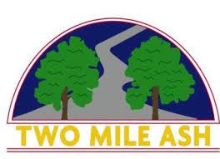

Dear Parents/Carers,

Snow White and the Seven Dwarfs Pantomime, Milton Keynes Theatre January 2023

Last year’s pantomime visit was so successful that we have decided to run this event again. We are giving you plenty of notice so that you can decide whether to go as a family or allow your little one(s) to come with us instead!

We are running two outings as follows:

If your child will be in either Year 4 or Year 6 this coming September:

Wednesday, 4th January at 7.00pm

If your child will be in either Year 3 or Year 5 this coming September:

Thursday, 5th January at 7.00pm

100 tickets have been reserved for each year group. Please note that tickets for our new Year 3 cohort will not be released for sale until September when these pupils join our school.

Tickets cost £10.15 each. Parent pay will be open for parents to purchase a ticket **from Monday, 18th July from 8.30am**. Please note that this will be on a first come, first served basis and only one ticket can be purchased per child. Further details about the evening will be sent home via the children in the autumn term, including a request for contact details and relevant medical information.

We really hope that your child/children can join us for this special event – we all loved last year and are sure that this coming pantomime will be as enjoyable!

Yours sincerely,

Debbie Ismail

Debbie Ismail