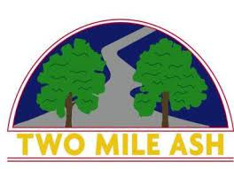

Dear Parent/ Carers,
Thank you all very much for your support, co-operation and understanding regarding our school closure earlier today. We never want to disrupt our children's time in school so the decision to close the school was not taken lightly and we only did so when it was absolutely necessary. As we're sure you're now aware, this was due to an issue with Anglian Water and effected many areas of Milton Keynes.
We are pleased to inform you that the school once again has running water and therefore will be OPEN tomorrow. We look forward to seeing all children tomorrow (15th July) to continue their learning as well as enjoying the last few days of this academic year with their class and teachers.
Once again, thank you all for your quick response earlier today.
Two Mile Ash School

