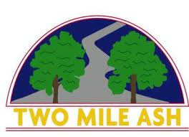

Dear parents/carers
Last week we took photos of a series of Sport Teams that have represented Two Mile Ash at major MK Schools or County events throughout the year. Many of these photos are now available at: https://www.tmaschool.com/news/galleries/
More will follow, including the Year 5/6 Boys Cricket and TMA Athletics photos
Many thanks
Mr Saville & Mr Hobley

