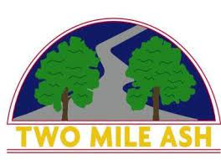

Dear Parent/Carer,
As you are aware, throughout the country we are experiencing high temperatures and we want to ensure our children are keeping as cool and comfortable as possible whilst in school. Therefore, from tomorrow (Wednesday 13th July) and until the end of this summer term (Thursday 21st July), we will be allowing children to come to school in PE kit every day, even if it is not their PE day. Please can children only wear TMA PE kit following our usual PE kit expectations; TMA red PE top, TMA black shorts, trainers.
Can we please also take this opportunity to remind you to ensure that your child is bringing in a water bottle, hat and sun cream every day.
Many thanks,
TMA School

