
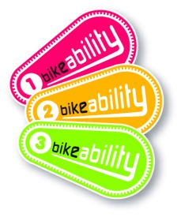
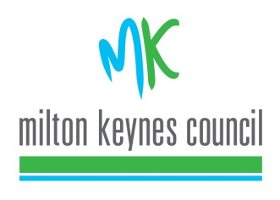
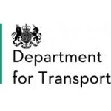
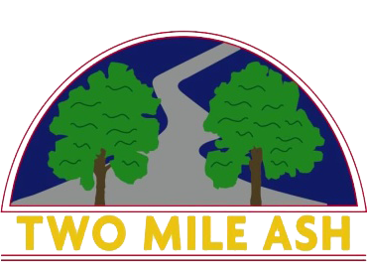

Year 6 Bikeability
Dear parents/carers,
We are very pleased to announce the opportunity for a further 16 Year 6 children to take part in a Level 2 Bikeability course at Two Mile Ash School. The course (split into 2 groups) will run over the total of 1 school day between Monday 18th July 2022 and Wednesday 20th July 2022.
Pupils will be placed into groups of 8 and told of the date(s) and times in advance for their course. Before signing your child up to this course, please read the information below which includes equipment requirements and prior cycling ability. Please do not book onto this if your child completed the course in June.
The total cost for the Bikeability course is £6.75. To sign your child up to the Year 6 Bikeability, please login to your parent pay account. Bookings open at 9am, Wednesday 13th July 2022 and close at 9am, Thursday 14th July 2022. Groupings will be confirmed and children informed of these on Friday 15th July 2022.
Bikeability Information:
Bikeability is the National Standard for Cycle Training. There are three Bikeability levels each designed to improve cycling skills, progressively taking trainees from the basics of balance and control, all the way to route planning and making independent journeys on busier roads.
Trainees must be able to ride a bike before attending any of these courses. If you or your child cannot ride a bike and would like to learn, contact the councils cycling team.
Bikeability Level 2 is delivered on quiet local roads and Redways and equips trainees with the knowledge and skills to deal with traffic on short journeys. It is usually taught at a ratio of 1 instructor to 6 trainees over 3 half day sessions.
Equipment - Trainees should arrive at the training session with appropriate clothing. In wet weather this should include waterproofs and in warm weather, sun screen and water. Trainees must have a helmet that fits and is not damaged. If a trainee arrives without a helmet or if the helmet is deemed unsafe by the instructor, they may not be able to participate. Full face helmets or helmets covering the ears or eyes are not permitted.

PRE-COURSE BIKE CHECKS
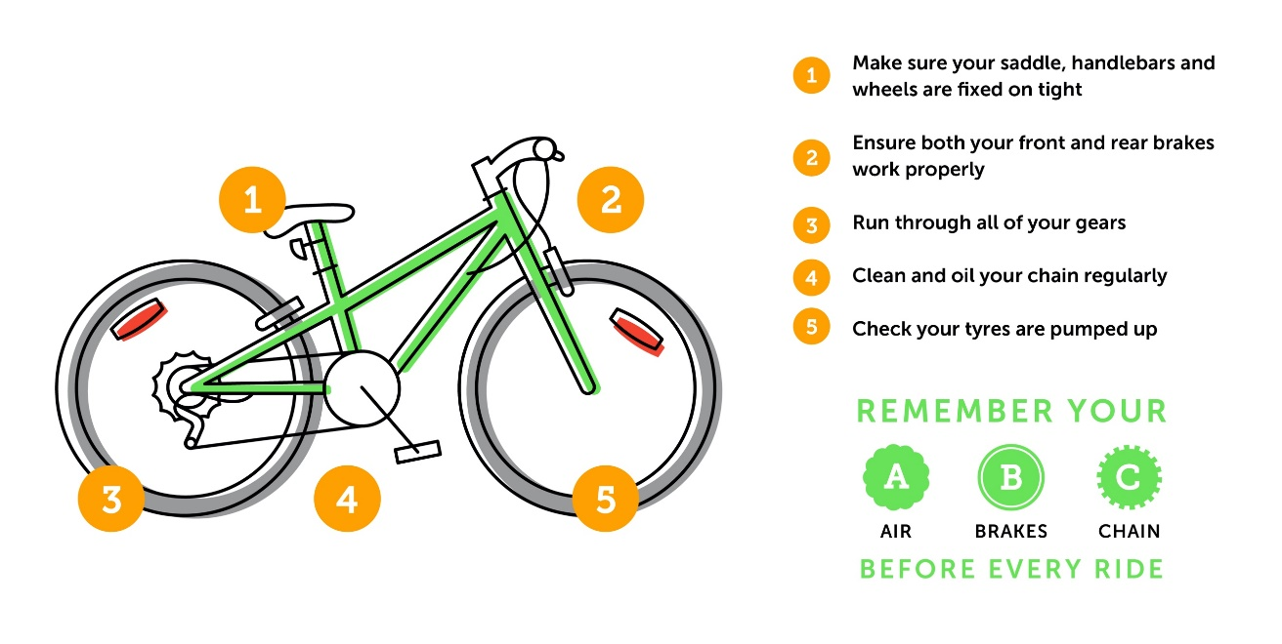

More information - To find out more about cycling in and around Milton Keynes visit www.getsmartertravelmk.org . If you have any queries about Bikeability speak to the Instructors or email cycling@milton-keynes.gov.uk or visit www.bikeability.org.uk

