Tuesday 19th July

Dear parent/carer,

The Year Six team look forward to welcoming the children back for the new academic year in September 2022. A tradition we uphold in Year Six, is putting on the new claret jumpers to signify the children’s transition to Year Six. The Claret jumper is an important part of the children’s ‘TMA DNA’. It represents the culmination of their last four years at TMA, the Year 6’s take on the role of leaders of the school. Being excellent role models for the rest of the children at TMA. Traditionally we hold an internal Claret assembly on the first day of term where the children switch from their Blue jumper into their Claret.

You will be able to purchase Claret jumpers from our uniform partner Maisies. Please click the hyperlink below:

https://www.maisies-superstore.co.uk/two-mile-ash-school/

Examples of claret uniform you can purchase:
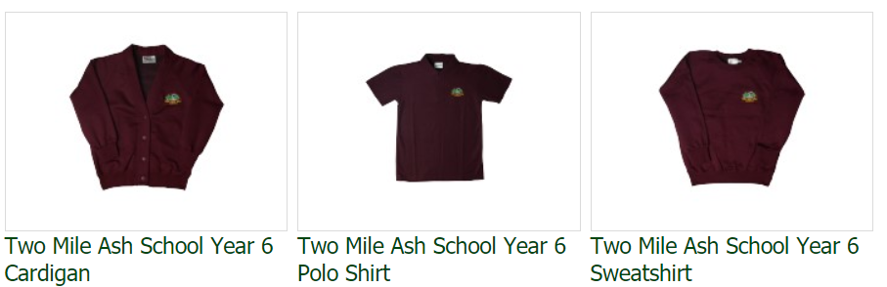

If possible, can your children wear their blue jumper on the first day back to school, so they can change into their new claret jumper during the first Claret assembly. Don't worry if you no longer have a blue jumper, the children can just take their claret jumper off and then put it on again in the assembly, to signify the transition to Year Six.

Have a good summer and we look forward to seeing you all on Monday 5th September.

Kind regards,

Mr Ruffett
Head of Year 6

