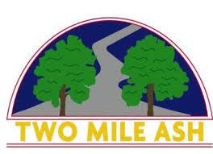

Dear Parent/Carer,

We are excited to inform you that the BBC local news team have asked to visit Two Mile Ash School and other schools across Milton Keynes, tomorrow morning, Thursday 15th September. They are wanting to capture footage of the different ways children across the city are remembering and reflecting on Queen Elizabeth II. Rev Mike Morris will be in tomorrow morning to lead an assembly for all children across the school and there will be different activities happening across the year groups.

Parents will be notified and will be required to sign a permission form if their child has been selected to be filmed during this time. Please ensure the children bring this slip in first thing in the morning so they can participate.

Any questions, please speak to your child’s class teacher.

Many thanks,

Two Mile Ash School

Sophie Haycock

Deputy Head,

Two Mile Ash School