13 September 2022

House Cross Country Races 2022

Dear Parents/ Carers,

We are very pleased to invite your child to compete in this year’s Two Mile Ash House Cross Country Races. All pupils across the school will score points for their house which will go towards overall year group and school totals – last year’s overall winners were Townsend House!

Each year group will participate in their own House Run during the school day on the following dates (all children take part):

- Year 3 – Tuesday 20th September 2022  - Year 4 – Wednesday 21st September 2022 | - Year 5 – Tuesday 20th September 2022  - Year 6 – Thursday 22nd September 2022

Children are asked to come to school in Two Mile Ash PE kit with a T-Shirt that is their House Colour. Here is a reminder of the Houses and colours:

- Brittain – Blue  - Emburey – Yellow  - Hawthorne – Black | - Rutherford – Red  - Townsend - Green
It is important that your child has comfortable trainers to run in. Please can you alsoprovide your child with a bottle of water.

If you have any questions regarding the event please contact us at: reception@tma.bucks.sch.uk

Thank you for your continued support and we wish your child a successful and enjoyable experience.

Yours sincerely,
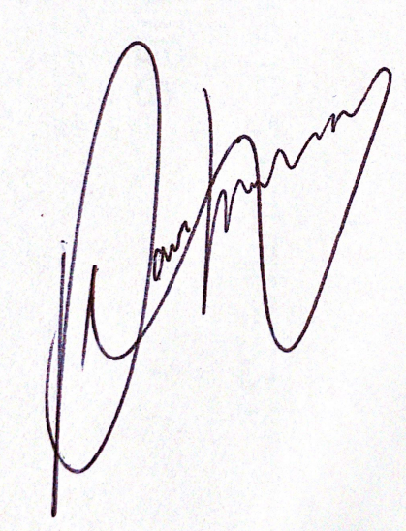
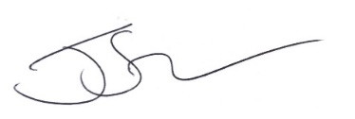
Mr. Saville Mr. Hobley
Head of PE PE Coordinator
Two Mile Ash School Two Mile Ash School

