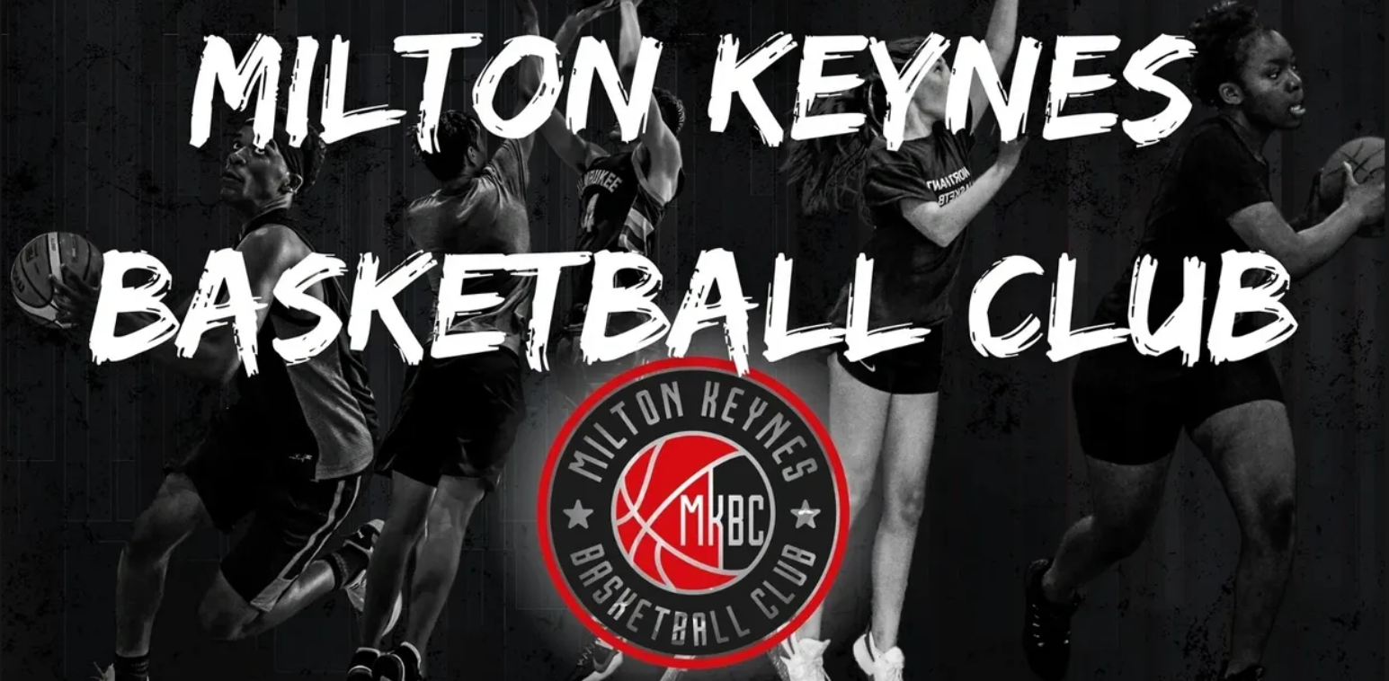
September 2022
Milton Keynes Breakers Basketball Club
Lunchtime Clubs at Two Mile Ash School
Dear Parents/Carers,
I am writing to inform you that Two Mile Ash School have secured opportunities for pupils to receive Basketball coaching from MK Breakers Basketball Club during lunchtimes. These sessions, aimed at boys and girls of all abilities, will be led by an experienced, qualified Basketball Coach at Two Mile Ash School.
There are only twenty spaces available per year group for a four-week block of sessions (dates listed below). The sessions are for 30 minutes.
As the sessions will run during lunchtime, children will be given time at school before the session to eat their lunch. Children will need to come to school in their PE Kit* on the day of the sessions, including their Red TMA T-Shirt, Black leggings/shorts/joggers, Black Jumper and Trainers. They should also ensure they have a bottle of water to take with them and have a jacket on wet days.
The total cost for the five sessions is £4.50. Bookings for these sessions go live on Parent Pay at 9am, Thursday 22nd September 2022 until 9am, Friday 23rd September 2022.
If you have any questions regarding this opportunity, please email Mr Saville at: finance@tma.bucks.sch.uk
Session Dates & Times:
Tuesdays:  September: 27  October: 04, 11 & 18 | Year 4 | 12:15-12:45pm
 | Year 3 | 12:45-1:15pm
Wednesdays:  September: 28  October: 05, 12 & 19 | Year 5 | 12:15-12:45pm
 | Year 6 | 12:45-1:15pm

*No Kit required on 28th September due to School Photos being taken.

Yours sincerely,
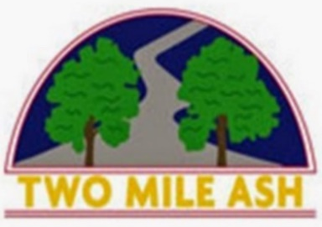
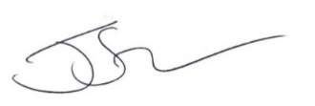
Mr. Jake Saville
Head of PE & Enrichment Coordinator

