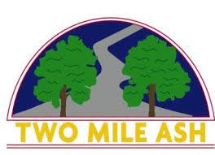

September 2022

Dear Parents/Carers,

Snow White and the Seven Dwarfs Pantomime, Milton Keynes theatre 2023

In January, we took 400 pupils to see the Jack and the Beanstalk pantomime which the children really enjoyed. This visit was so successful that we have decided to run this event again for the third year.

We are running two outings as follows. Parents will be asked to drop their child off at the theatre and collect them after the performance.

Years 4 and 6: Wednesday, 4th January at 7.00pm

Years 3 and 5: Thursday, 5th January at 7.00pm

Tickets cost £10.15 each. Payment must be made via parent pay. **Please note that this will be on a first come, first served basis and only one ticket can be purchased per child.** There are 100 tickets available for Year 3. Parentpay will be open for all of Year 3 on Wednesday 14th September and payment can only be made via this system.

Further details about the evening will be sent home via the children after the closing date, including a request for contact details and relevant medical information for those children who have been successful in securing a ticket.

We really hope that your child can join us for this special event – we all loved Jack and the Beanstalk last year and are sure that this coming pantomime will be as enjoyable!

Yours sincerely,

Debbie Ismail

Debbie Ismail